The Amazing Videos of Taekwondo
Milestone 1 Part A

Team member names below
Benton Li, Bowen Chan, Chunxia Zhao, Kory Li

Dec. 6, 2014
CS 174
Group 3: Group I Don't Know
Assigned domain: Taekwondo

Contents
Individual Contribution Summary 3
Introduction 4
What have been accomplished in this milestone 4
Data correction and preparation 5
Restoring Data 5
Data processing 5
Data correction 5
Tagging videos 5
Video info modifying site 5
Login/Registration 6
Cookies for storing login info 7
Favorite videos 8
Additional info 9

http://www.sjsu-cs.org/classes/cs174/sec2/chan/cs174project/milestone1/

Individual Contribution Summary
Student Name | Technical part | Report drafting
Chunxia Zhao | - Completed part A.  - Insert all the videos into a blank fun_video database table and recover all rows of data.  - Remove 4 duplicate videos.  - Corrected discrepancies in all the videos, including all tags, most high resolution settings and some repeat titles(different links).  - Provide script(s) to allow users to retrieve and correct video information. Created index.html, enterData.php, entry.php, modify.php, welcome.php, recovervideo.php, updateinfo.php, verify_input.php, viewData.php, dbconnect.php. | - Wrote report of my own work, part of introduction, Data correction and preparation.
Benton Li | - Completed part B.  - Implemented login and registration pages  - Fixed various errors in other member’s files  - Created users sql table for use. | • Wrote in the report of my own work.
Kory Li | - Work on Part C  - Added form to allow users to store login information for the duration of 1 minute as a cookie. | - Provided screenshot of Part C and filled out parts pertaining to role.
Bowen Chan | - Worked on Part D  - Favorite Video  - Fix various code  - Created a favorite video table  - sort and pagination as well as nav bar | - Wrote my own work  - compiled the documents

*one page or less for this table, don’t put lengthy description to go beyond 1-page.
* add additional rows or columns as needed

Introduction

What have been accomplished in this milestone
your work is hosted under website: http://www.sjsu-cs.org/classes/cs174/sec2/chan/cs174project/
whose web and database account are used in hosting this website: Bowen Chan

Accounts for testing login info:
- Local Server

Describe what you have accomplished in bullet form:
- Create and design: index.html, enterData.php, entry.php, modify.php, welcome.php, recovervideo.php, updateinfo.php, verify_input.php, viewData.php, dbconnect.php, login.php, logout.php, register.php
- Develop …
- Data: in addition to fun_video table, also included login table to track email and password.
- …

Data correction and preparation

Restoring Data
Show how you recover all rows of data from given sql file.
Imported sql file to local database and recovered all rows. Wrote a script viewData.php to open data in a web browser.

Data processing
Describe how you remove videos that are either duplicated , with view counts lower than 50,000, or not matching the domain from the given data
Sorted data by title and clicked on each video to open in a new tab. Double checked data and made corrections when needed. During this process, duplicated videos were discovered and removed. No view counts below 50,000 or non-match domain discovered.

Data correction
Describe how you correct any discrepancy you notice in any of the videos.
There are a few that have either incorrect title or repeated title, probably due to the copy & paste process. Correct those. Also most videos had incorrected highest resolution setting. Changed those, too.

Tagging videos
Describe how you correct and/or add tags to better characterize videos
All videos were tagged as "sport" or "sports" or something like "Education". I retagged them as "taekwondo" and some more specific term such as "round house kick" to better characterize them.

Video info modifying site
Describe how you provide script(s) to allow users to retrieve and correct video information. Make a link to this script on your startup homepage and require user login to access such a link.
Narrated screenshots to describe the workflow is needed.
On startup homepage, I provided a linked to enter site, which is linked to login page. User can also choose to register, which is also provided on the startup homepage.
Once user logs in and submits, a welcom page is loaded. User can choose to add new video, browse existing video collection or logout.
When user chooses to browser existing videos, all videos are loaded and 2 links are provided to modify any video.

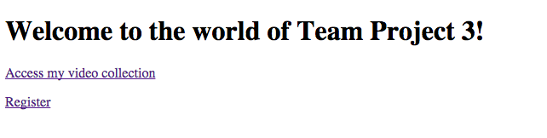

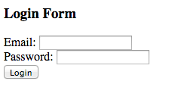



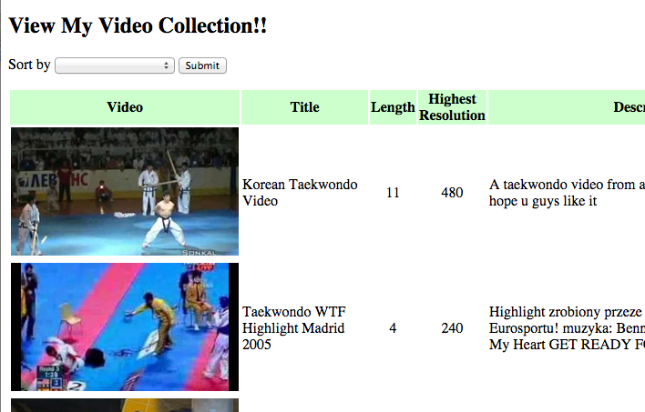



Login/Registration
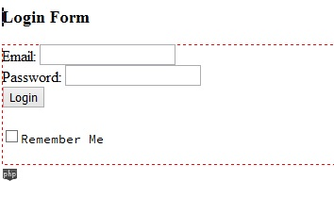
Simple login page. This page will redirect you to index.php when you finish logging in.

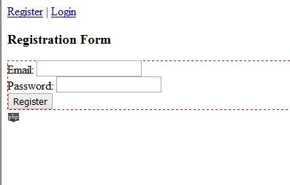
Registration is page is almost the same, but this page will put your information into the sql server. You can now log in after you register.

Cookies for storing login info
Narrated screenshots to describe the workflow is needed.

Login form now has checkbox to allow users to store their login Email and Password as a cookie that will expire after 60 seconds.
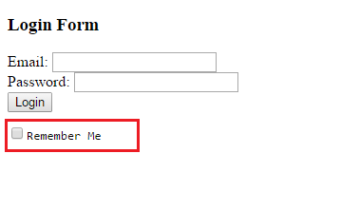
Checks to see if checkbox was selected. If so, store information to a cookie.
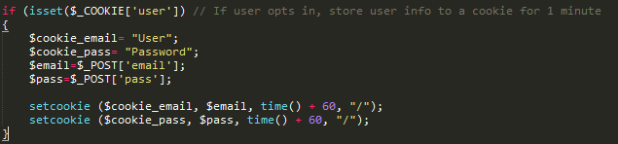

Favorite videos
Show how you use sessions to store and retrieve favorite videos selected by users.
Narrated screenshots to describe the workflow is needed.

1. In the login, the user is now the 'sess_users' which will be stored as we use sessions. This will allow server to recognize who is currently logged in.

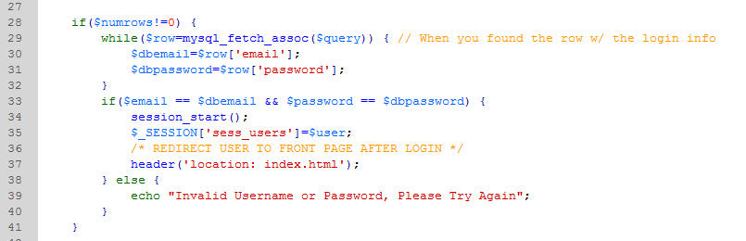

2. So the first thing I wanted to do is create a table where it would store all the favorite videos per each users.

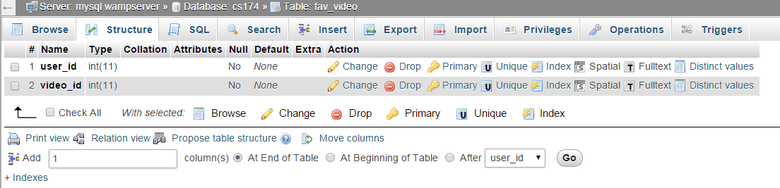

3. Now that I have a place to store the data, I want to create a button on the table that would allow a video to be favorite. 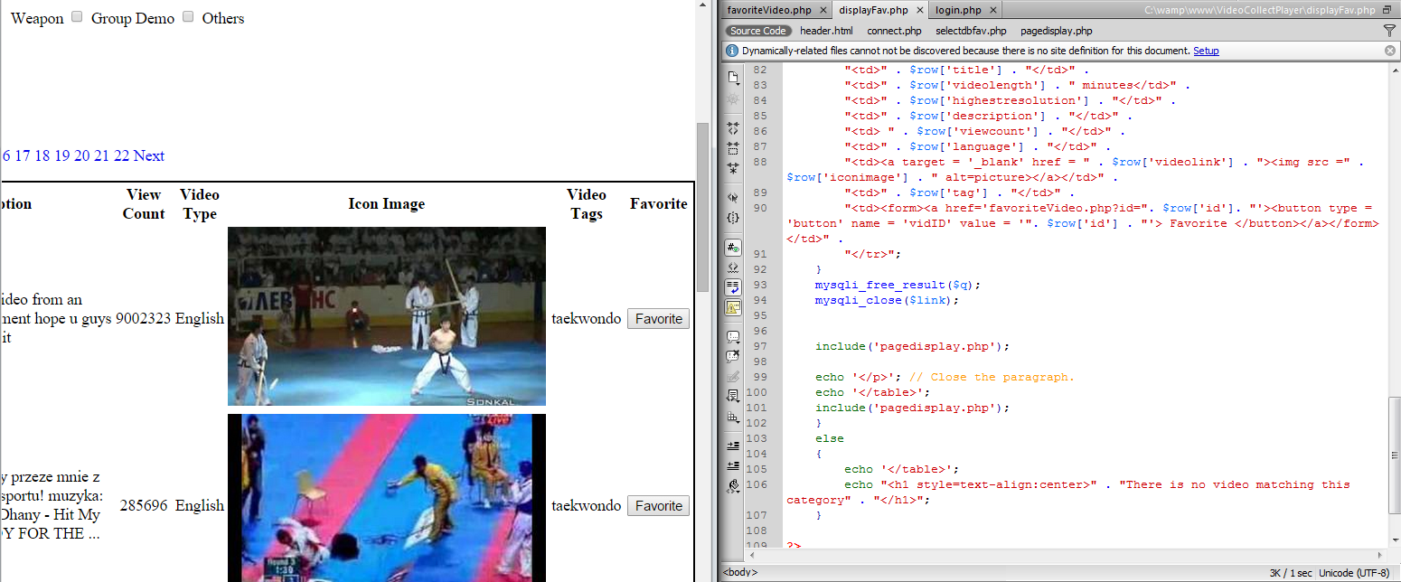

4. Once that was done, Now was to handle the data. You want to ensure that a user was signed in.

5. After you have that data, you are able to store the userID and vidID into the table, while checking if that data is already set.

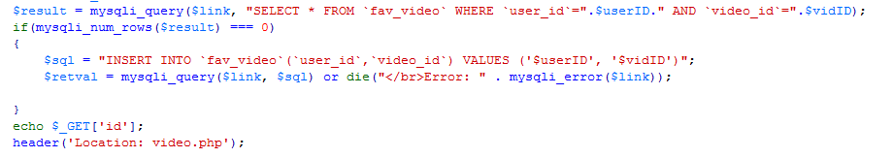

6. Now we pull the data through inner join only looking for the values based on the id.

Additional info
Describe any other relevant items here.

http://www.sjsu-cs.org/classes/cs174/sec2/chan/cs174project/milestone1/

